No images? Click here


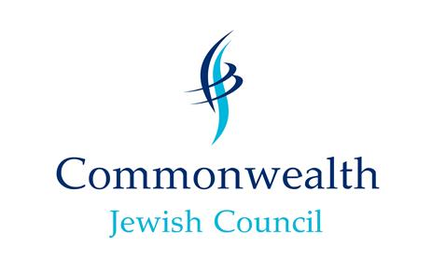

Connecting, Supporting, Representing

Wishing you all a Happy Passover - חג פסח שמח

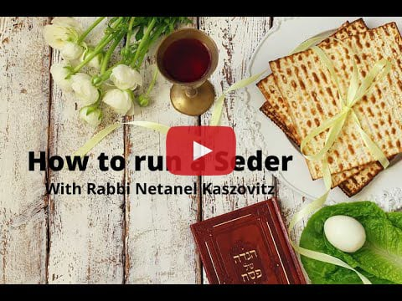

  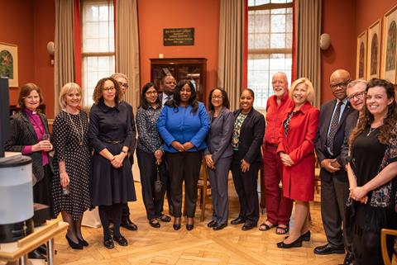
  CJC Diplomats Seder
  Nearly half the countries of the Commonwealth were represented, to hear Clive Lawton, the CJC’s Chief Executive, lead an abridged version of a traditional Passover evening meal. He helped those attending discover how a Seder feels for Jewish families around the world and by the end of the evening, had all present lustily joining in with the concluding songs.
  During the course of the event, Pesach themes were explored, as our ancient tradition talks of slavery and antisemitism, which sadly are still scourges today.
  HE Ralph Goodale, Canada’s High Commissioner in London, commented on how this experience fitted so well with his positive encounters with his own local Jewish Community back in Regina, Saskatchewan. Mrs Patricia Chanda, Charge d’ Affaires of Zambia was pleased to have finally been able to attend such an event in person having participated in the Zambian Jewish Community’s virtual zoom Seder last year.
  Both the Commonwealth Foundation and the Commonwealth Secretariat were also represented at the highest level by Dr Anne Gallagher, the Foundation’s Director General, and Baroness Patricia Scotland, the Commonwealth’s Secretary General.
  Baroness Scotland remarked that the constant reminder to the Jews, as expressed in the Seder, that they had been subject to slavery must explain why they are so ready to fight for the freedom of others.
  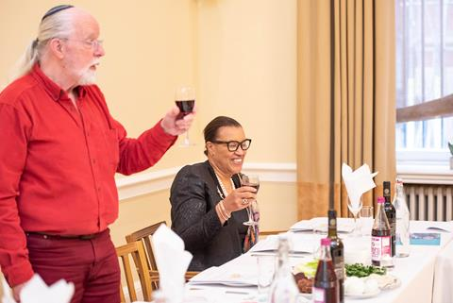
  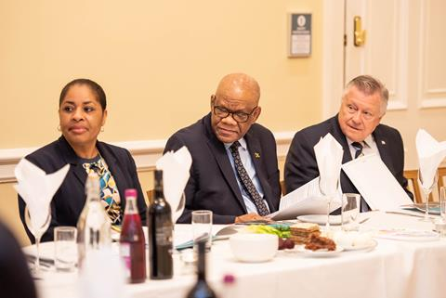
  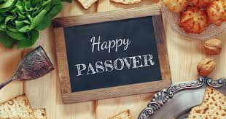
  Planning a Seder
  Rabbi Natanel has put together some wonderful videos to help you in your seder planning.
  Rabbi Natanel is the Rabbi of the Nairobi Hebrew Congregation and works with us to offer support to the Jewish communities in Tanzania and Uganda.
  You can find the full list here
  Upgrade your seder - if you are still unsure what to include in your Passover Seder, here are some liberal Haggadah templates to mix and match blessings, songs, activities and artwork.
  Click here to build and download your Haggadah
  Twelve delightful Pesach Bytes serving up self-directed learning and fun, compiled of curated videos, games and activities (both digital and hands-on) for children to dive into the story and customs of Pesach.
  Click here to Ji Tap interactive resources
  Don't passover that perfect recipe - whether you’re making Passover for the first time this year, or are a seasoned veteran, there are over 70 wonderful and varied Chametz free recipes here to make it easy
  Click here for that perfect recipe for your Seder table
  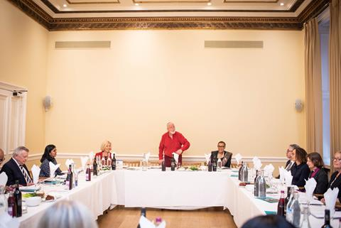
  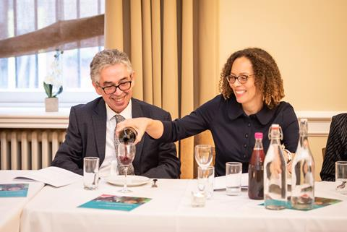

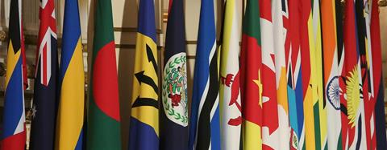  CHOGM  CHOGM is on at last!  Usually every two years all the Heads of Government meet at the Commonwealth Heads of Government Meeting (CHOGM) which is the biggest and most significant event in the Commonwealth calendar. However, Kigali, Rwanda has been waiting to receive this gathering for two years (they were scheduled to host it in 2020 but Covid put paid to that). Now at last the event is back on for June 2022 and at that occasion, Rwanda will become Chair in Office, taking over the from the UK who have held it for this extraordinary period of four years. The CJC, as an officially accredited organisation, has the fortunate privilege of being able to attend and we shall indeed be there, contributing to the discussions, making sure that a principled and strong Jewish voice is heard on the issues of the day. | The Queens Jubilee  Though she won't be in Kigali for CHOGM - probably the first one she will have missed - Queen Elizabeth II will be celebrating her 70th year as Head of the Commonwealth this year. Of course, she is not Head of State for the majority of Commonwealth nations - indeed Barbados just recently became a republic, an event which Prince Charles endorsed with his presence at their new President's inauguration, but surely everyone in the Commonwealth, not least the CJC, recognises the remarkable example Her Majesty has shown in her utter dedication to public duty and service. All our CJC communities can wish her mazaltov on this unparalleled milestone and wish her 'ad meah v'esrim', bis hundert und zwanzig, for 120 years...  In the meantime, if you want to do something practical and very Jewish to mark the occasion, plant some trees and make a (further?) contribution to the 'Queen's Commonwealth Canopy', an inspiring vision of wrapping the world in a belt of green. And if your government is not on board with this yet - most are - then lobby them to get with the programme!

The CJC are offering free places to attend this LSJS virtual matzah ramble, please contact robby@cjc.org.uk for a code to join.
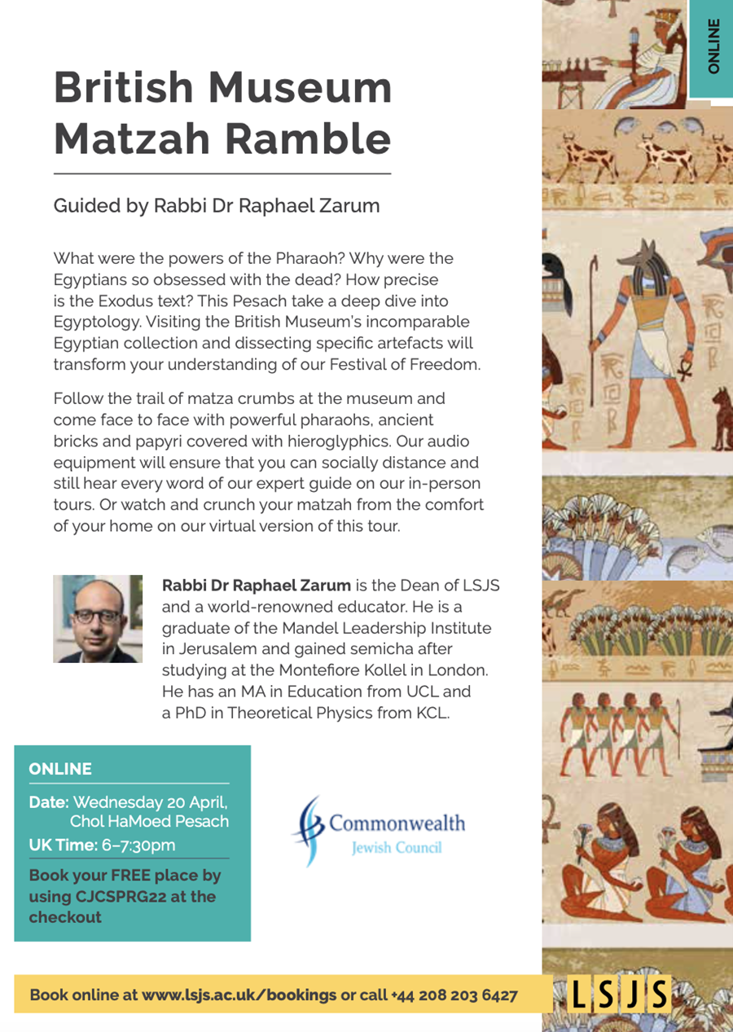
LSJS is seeking to profile some of our communities and wants to interest world Jewry in the realities of Jewish life in the Commonwealth. To this end they will be hosting presentations by our Jamaican Country Vice-President, Ainsley Henriques, and Yehudah Amir, our Tanzanian country Vice-President during their summer term (May to July) so watch this space for more on this.

Development Fund - Small Grants Available!

We are offering small grants! If you have a good idea which will enrich your community and its activities – perhaps to help members to get more involved in local.
We have also put together a summary of Recommended Programmes designed simply to uplift activities within Jewish communities, enhance intercommunity activity, make contributions to wider society and ways of engaging and enriching leaders and potential leaders for your community.
Click here to check out the Recommended Programmes
We want to spend the funding on valuable and fruitful projects created and implemented by you! So please let us know if you have an idea or would like help in developing an idea and we can help make your vision become a reality!

Please email robby@cjc.org.uk for more information.

SUPPORT CJC | MEET CJC LEADERSHIP

Trustees  The Lord Mendelsohn (President)  Nigel Cohen  Laura Marks OBE  Howard Rosen CBE  Council of Ambassadors  Lady Morris of Kenwood CBE  Dorothy Reitman CM  The Lord Polak CBE  ​Rev Malcolm Wiseman OBE | Presidents' Forum  The Lord Mendelsohn (Chair)  Marie van der Zyl (Europe)  Jillian Segal (Australasia)  Heather Feynes (Western Hemisphere)  Ann Harris (Africa)  Officers  Clive Lawton OBE JP (CEO)  Robby Hoffman (General Secretary)  Anna Lawton (Campaigns and Public Affairs)  Maureen Gold (Consultant)

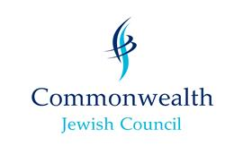 |  Share   Share   Forward
  Commonwealth Jewish Council
  BCM Box 6871
  London
  WC1N 3XX
  Registered in England
  Charity No. 287564
  You are receiving this email because you opted to receive updates and alerts from CJC. If you wish to no longer receive these emails, please click the unsubscribe in this email.
  Preferences | Unsubscribe

